Image result for blank facebook profile pictureImage result for blank facebook profile pictureImage result for blank facebook profile pictureImage result for blank facebook profile pictureImage result for blank facebook profile picture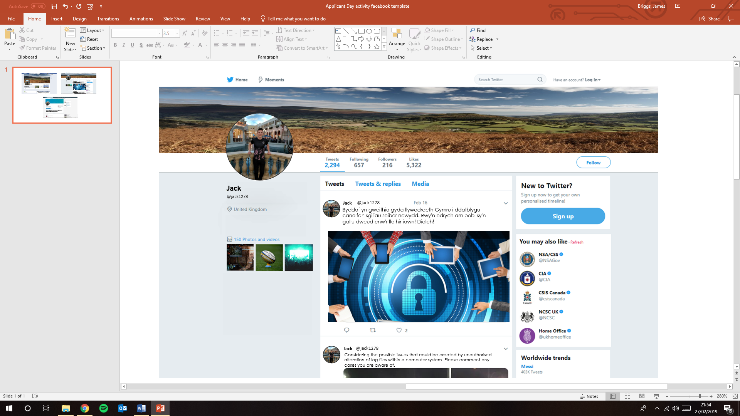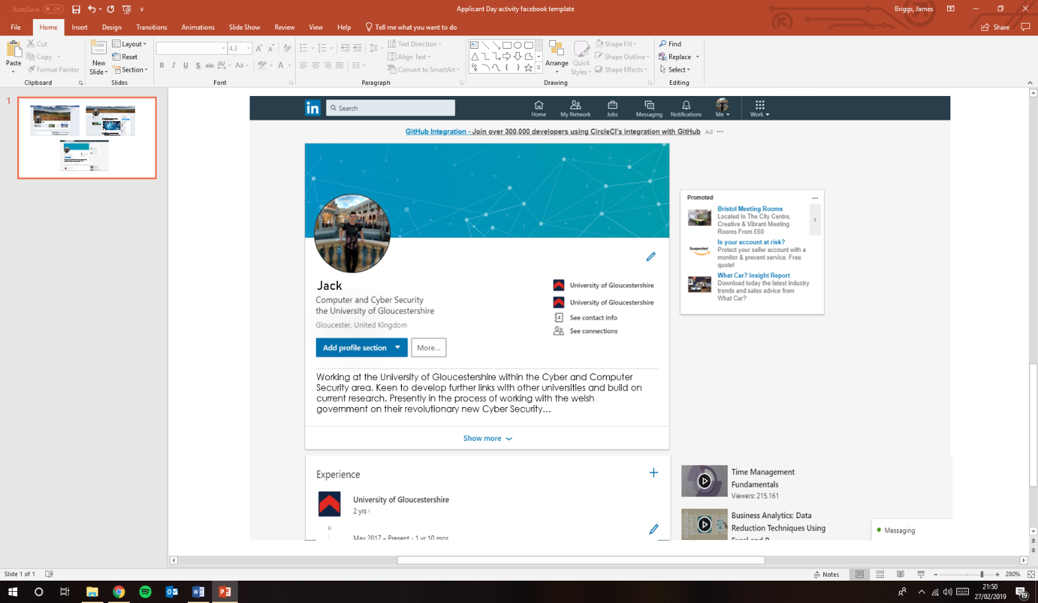

**Bill**

**Bill** @billy122

**Bill** @billy122

**Bill**

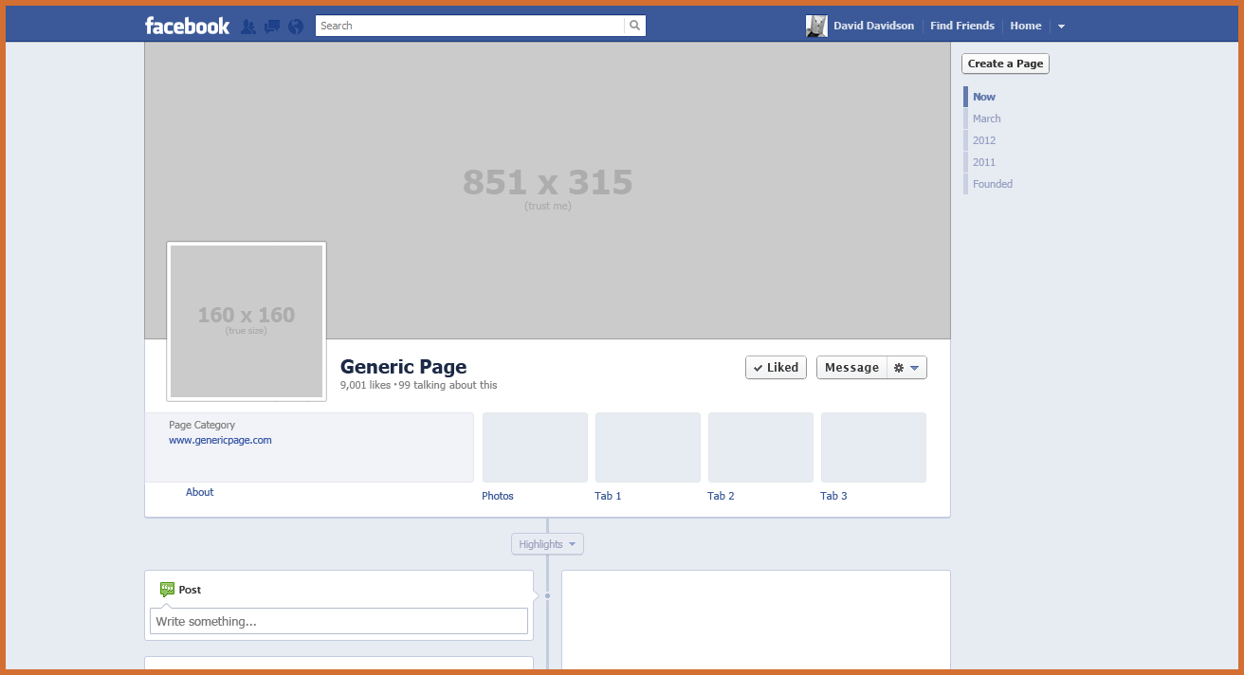

**Bill**

**Find Friends**

**Home**

**Bill**

Works at:

UNIVERSITY OF GLOUCESTERSHIRE

Current address:

The Green, Heywood Ln, Tenby SA70 8EU

Bill is visiting llanfairpwllgwyngyllgogerychwyrndrobwllllantysiliogogogoch

January 17th at 16:19 PM

Visiting a different part of Wales for a few days. Really good to see a such amazing views and of course the iconic place name too!

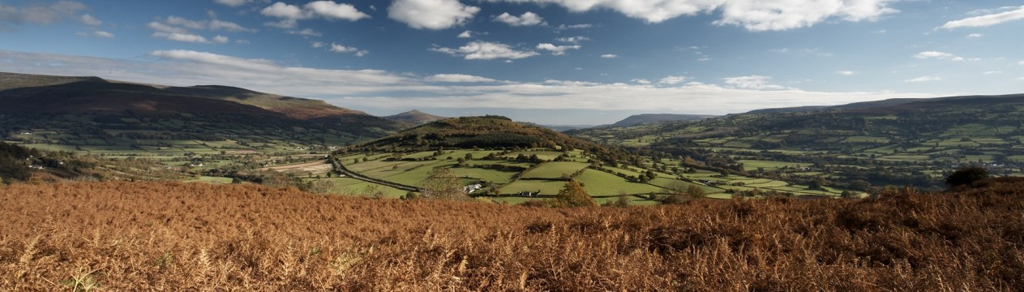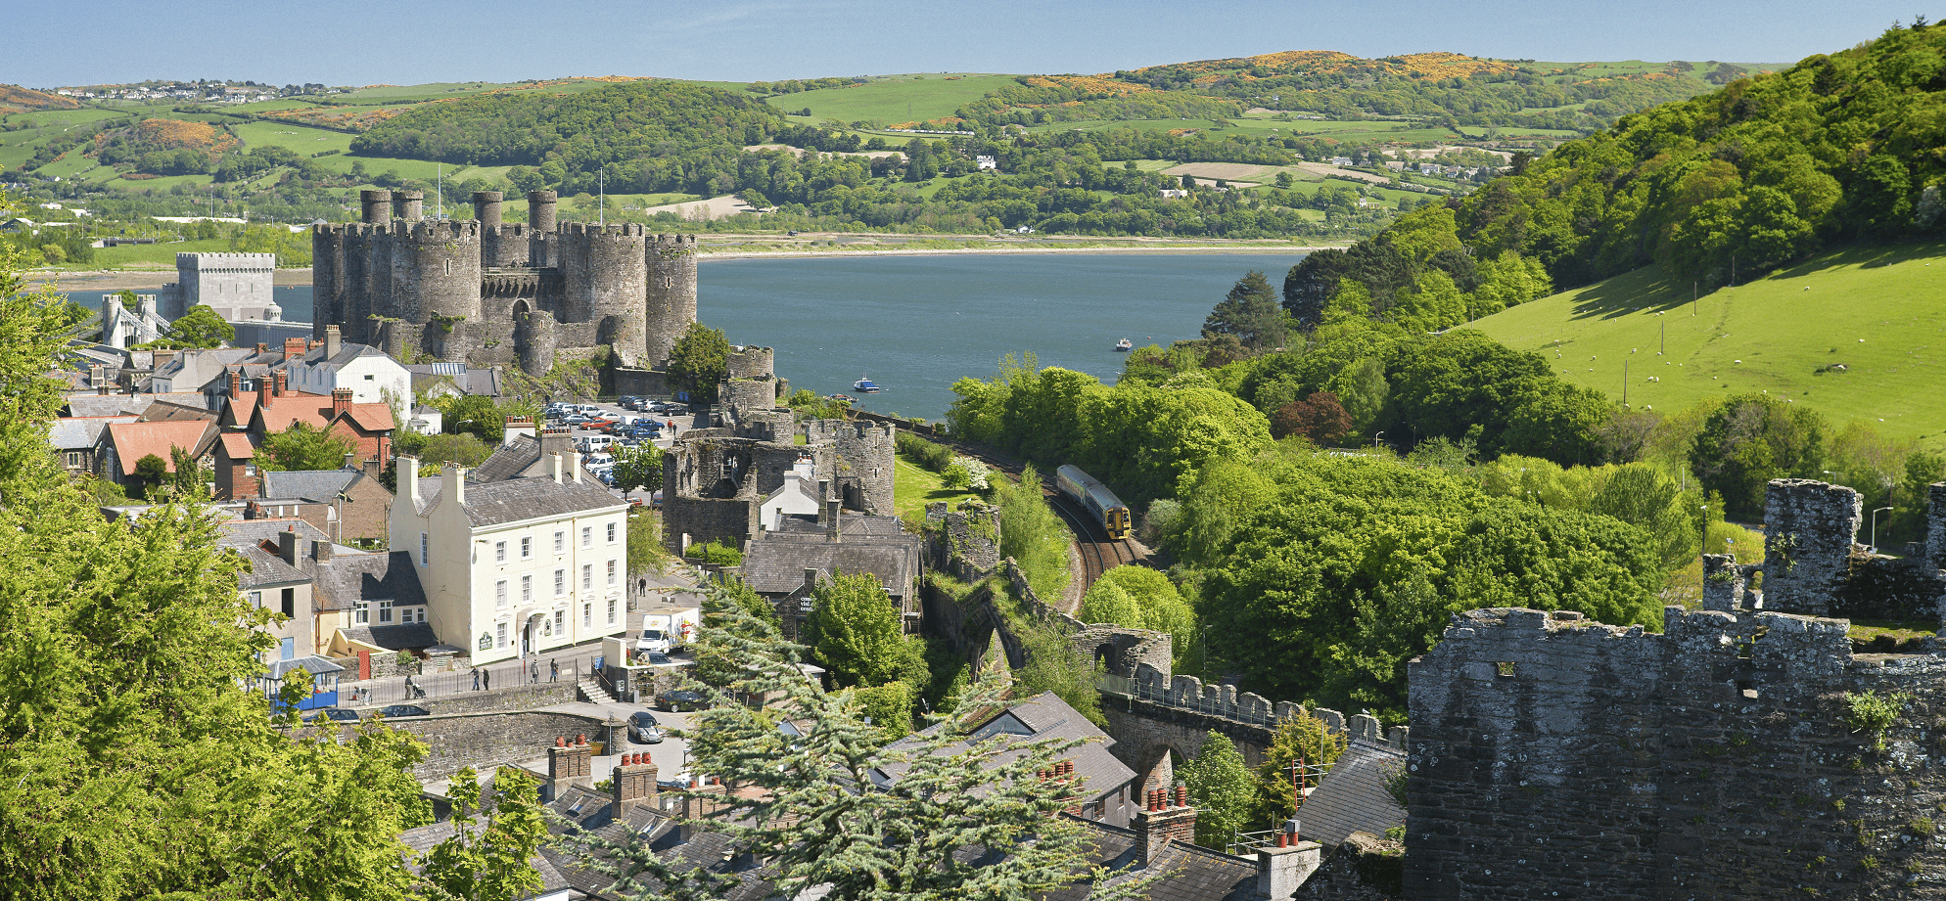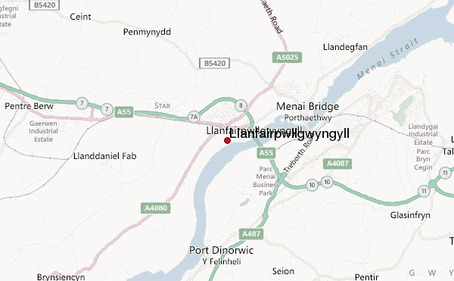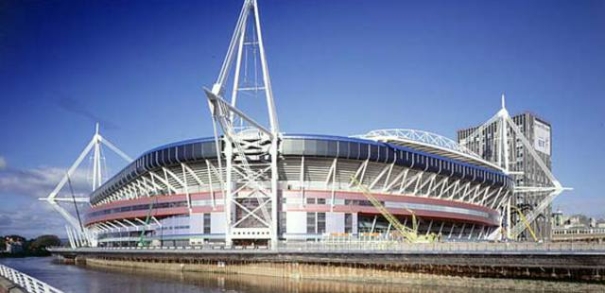

Send

Attach

To:

Subject:

From:

